Student Personal Computer
Autodesk Installation
Be sure to have access to your @huskers.unl.edu email account first at: http://mymail.unl.edu
Go to http://students.autodesk.com/ and create an Autodesk account or use your existing account. You must use your @huskers.unl.edu email address when you create your account with Autodesk.
Click on “Sign In” at the top of the page to get started. This opens a login screen where you can now enter your @huskers.unl.edu email address.
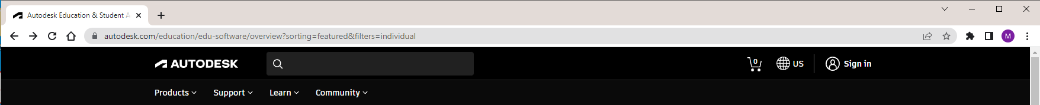

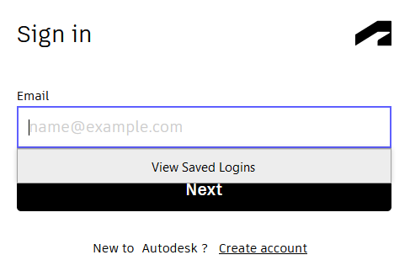
If you do not have an Autodesk account yet, click “create account” to create one.

Once you have logged on, click the “Students” tab at the top. 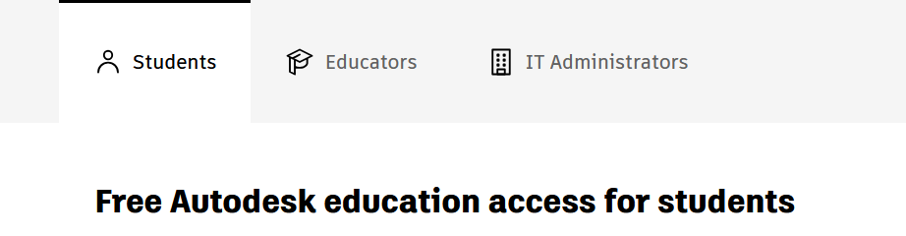

Scroll down. Click “Select Products”
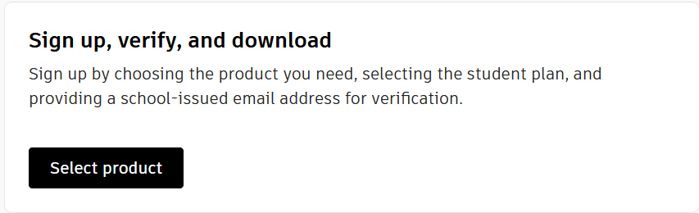

At some point, you will be prompted to confirm your eligibility. You will need a picture of your UNL ID or a copy of your transcript to complete this step. For incoming freshmen without a UNL ID, you can use an unofficial transcript. To get your unofficial transcript, log into MyRed. Underneath the Academics tab, select Unofficial Transcript. You should be able to download the unofficial transcript from there and then upload it to verify your enrollment.
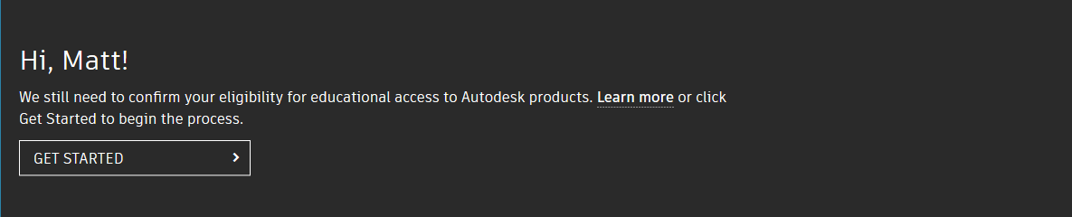
Herbie

Fill out the next page and be sure to enter “University Of Nebraska - Lincoln” as the “Name of the educational institution.” It should auto-populate, and you can click it to select it.
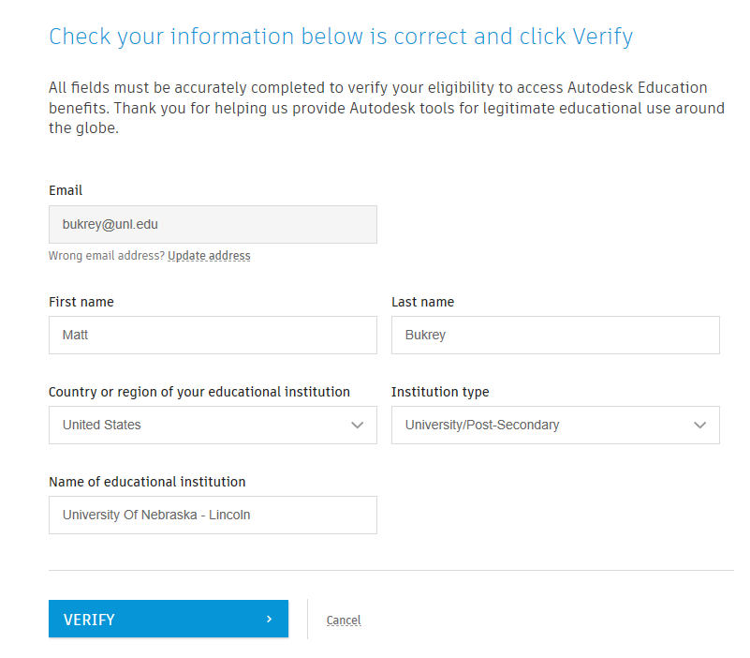
herbie.husker@huskers.unl.edu
Husker
Herbie

After you click ‘verify” you will need to upload a picture of your ID or transcript.
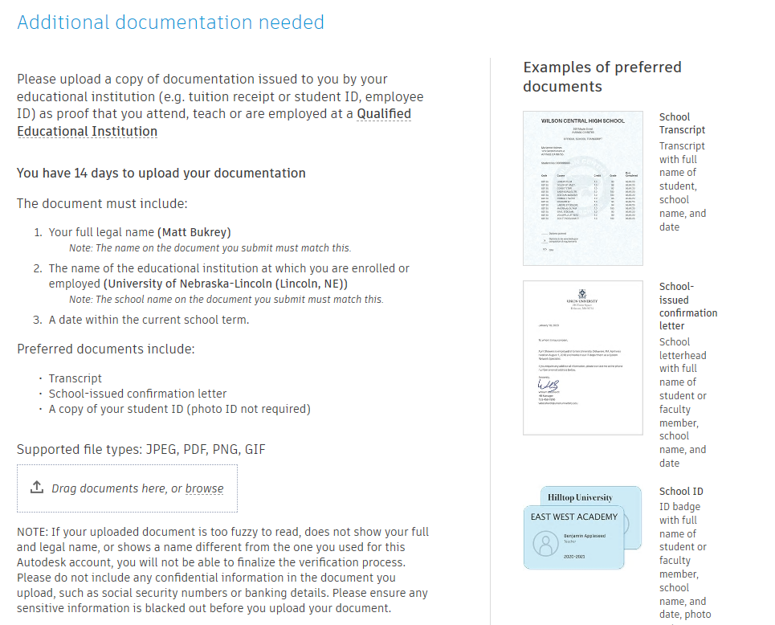
You will receive an email after the request is processed. It may take up to 20 minutes.
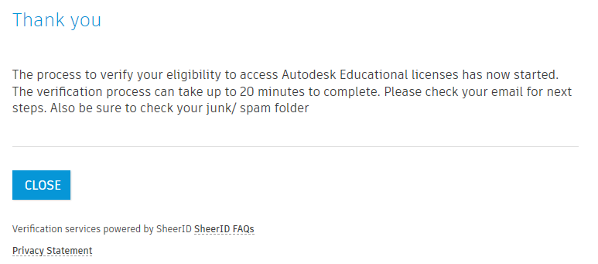
Once you get this email (check your SPAM filter), you can proceed. You can click the “GET PRODUCTS” link in it to go back to the Autodesk website and install your software.

Locate Revit, AutoCAD and AutoCAD Architecture on the list of products.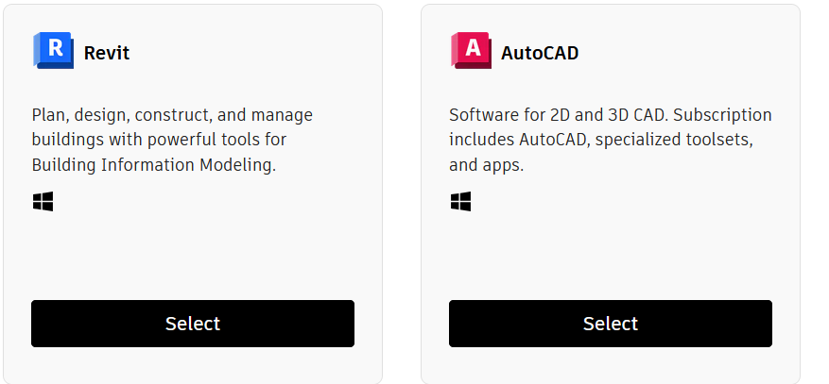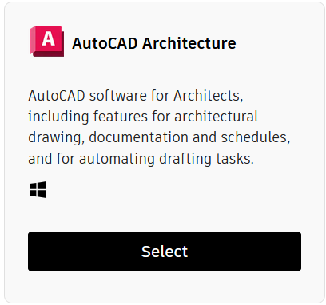
For some reason, this is the next box that appears. Click “Access products”.
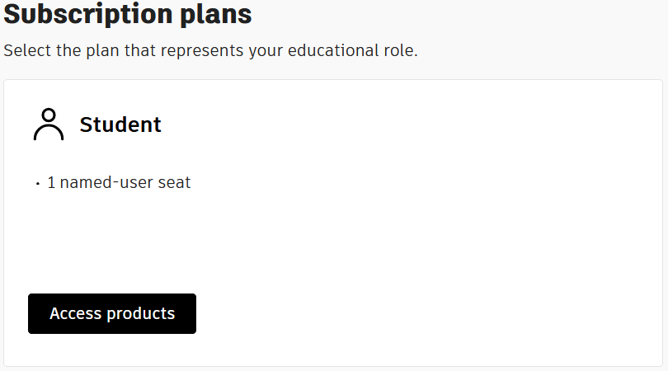
Locate one of the programs you need and click the “Install”
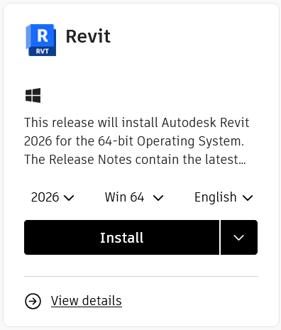

This will download a small program to your “Downloads” folder. Double-click it to begin the installation process. You will repeat the process for the remaining programs.
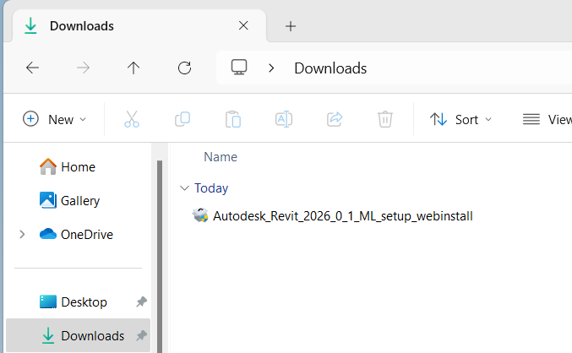

This will start the actual installer for the program. 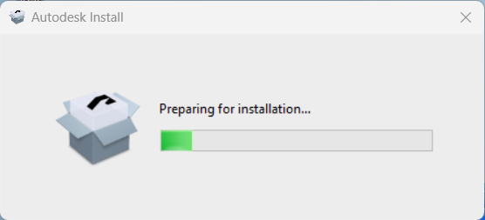

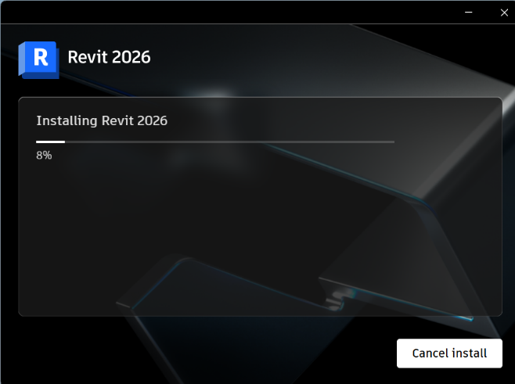
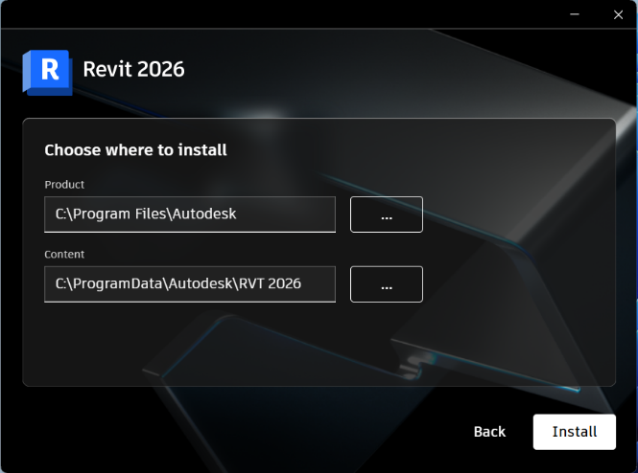
Click “Install” to begin.

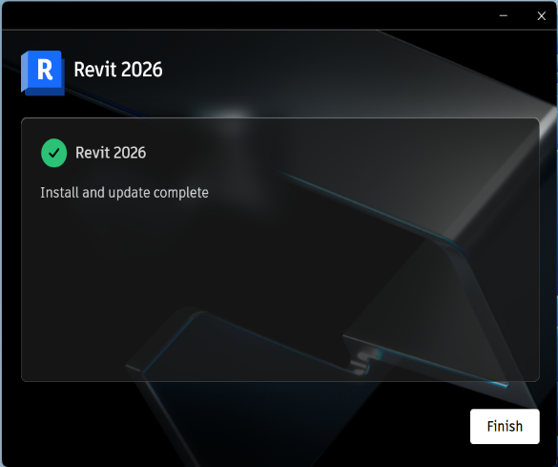
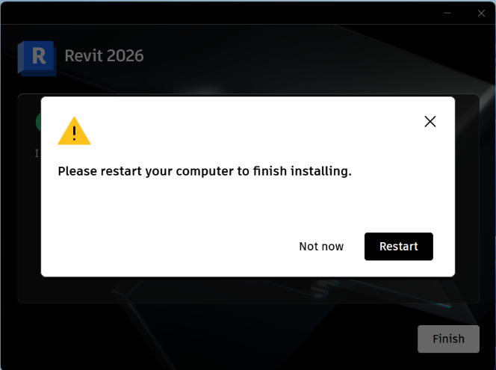
Do not restart yet. Click “Finish”

Open the program by double-clicking the icon on your desktop. After it opens, the sign-in page will appear. Click the “Sign in with your Autodesk ID” 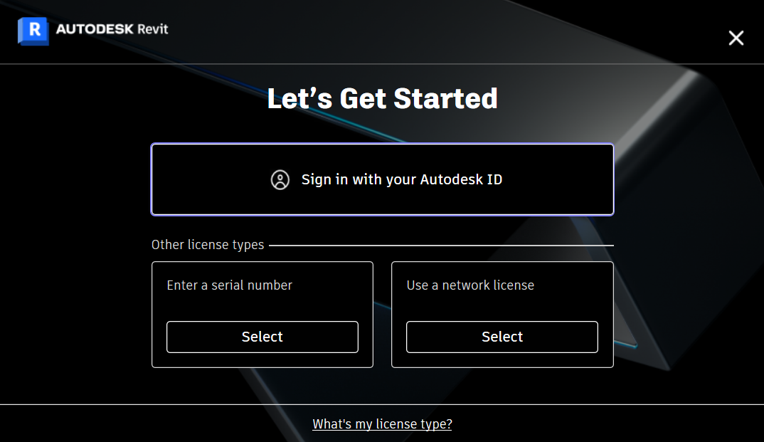

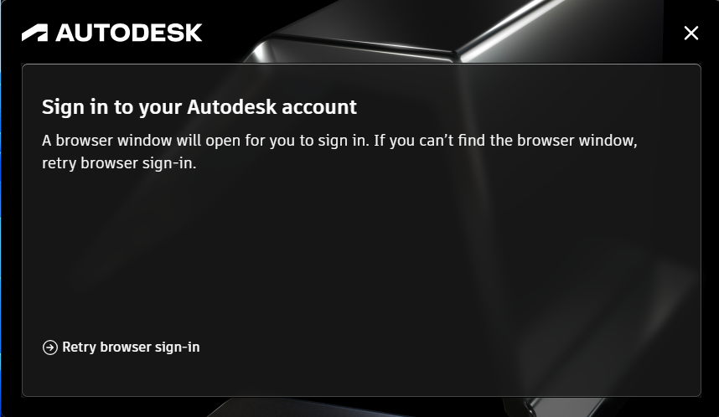

Your default browser will open. Enter your username@huskers.unl.edu email address and Autodesk password to finish.
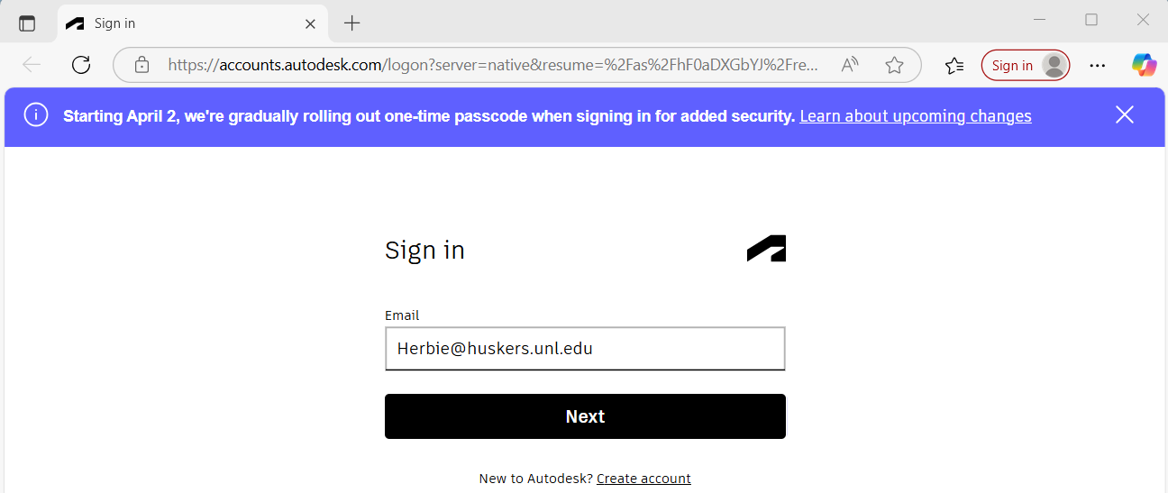

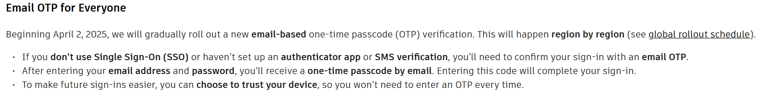
Click “Go to product” to open the program. You can now close the browser window.
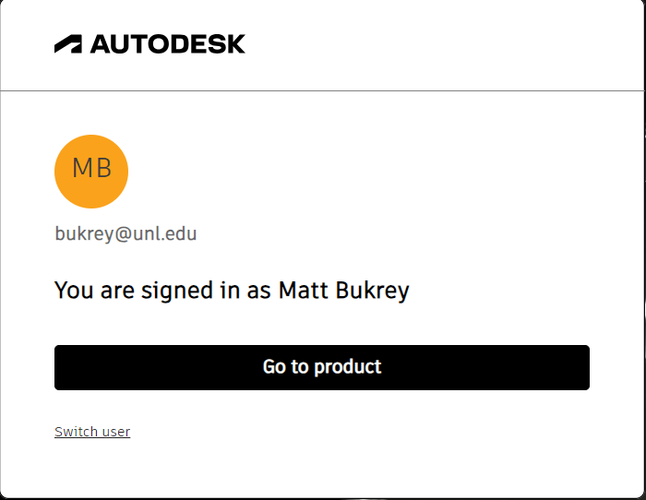
Herbie Husker
Herbie@huskers.unl.edu

